Blockchain Fundamentals

Overview by Harshit Jain

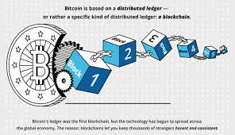

Topics to be covered are:

1. What is blockchain ?
2. Understanding SHA 256 algo.
3. Immutable ledger
4. P2P network and its advantages
5. Mining(Nonce and cryptographic puzzle).
6. Byzantine Fault Tolerance
7. Concencous protocol (POW).
8. Blockchain visual demo.

That’s all…..after completing this..you will be able to have strong foundation in blockchain………

Target 6 days…………..

